Read a book outside in the fresh air
Read your favourite book
Read a non-fiction book
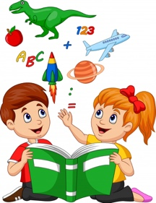
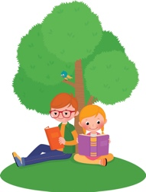
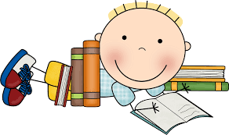

Reading Challenge!

Complete as many as you can and upload the photos to Tapestry!
Read a book that has animals in it
Read a book that rhymes
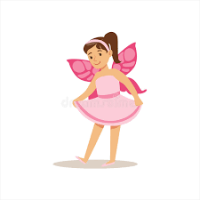
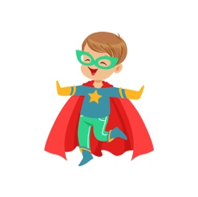
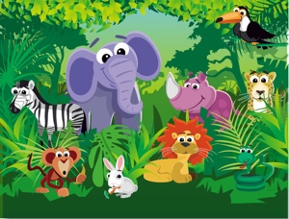
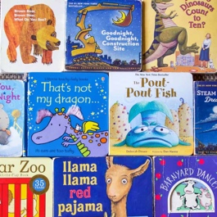
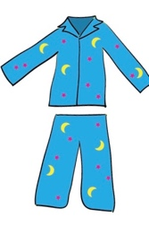
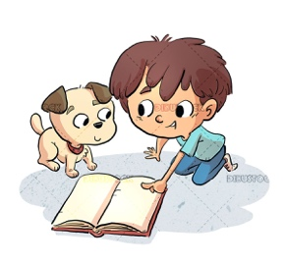
Read in your pyjamas
Read to a pet or your favourite cuddly toy
Read a book in your favourite dressing up costume

