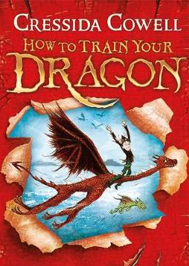
How to Train Your Dragon
Chapter 6 – Meanwhile, deep in the ocean
Chapter 7 – Toothless wakes up
Dictionary Corner
There are lots of new and interesting words in this chapter. Use a dictionary or ask a grown up what these words mean.
- solemnly
- dominate
- indignantly

- What does the phrase ‘Underwater desert’ suggest?

- How do we know Hookfang and Newtsbreath mean to doToothless harm?

- What role do you think the sea dragon might play in the rest of the story?

- Fishlegs is intelligent and quick thinking. Do you agree? Disagree? Use examples.

Have a go at writing your own sentences in Dragonese. Underneath each one write what it really means.

