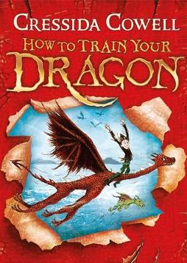
How to Train Your Dragon
Chapter 5 – A Chat with Old Wrinkly
Dictionary Corner
There are lots of new and interesting words in this chapter. Use a dictionary or ask a grown up what these words mean.
- vaguely
- contentedly
- reproachfully

- On page 76 why does Old Wrinkly turn his laugh into a cough when he is talking to Hiccup?

- When Old Wrinkly uses the expression ‘size is relative’ what does this mean?

- Why is Hiccup reluctant to admit he can talk to dragons?

- What have the boys started to call Hiccup?

Old Wrinkly describes a hero of the future as ‘clever and cunning, not just a big lump with overdeveloped muscles. Draw a picture of a ‘Future Viking Hero’ and list some of the qualities they have.

