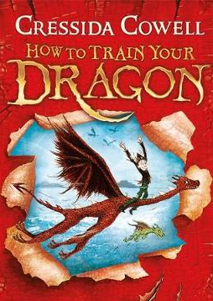
How to Train Your Dragon
Chapter 4 - How to train your dragon
Dictionary Corner
There are lots of new and interesting words in this chapter. Use a dictionary or ask a grown up what these words mean.
- viciously
- solemn
- hullabaloo

- Why does Snotlout suggest ‘Sugarlips’ and ‘Babyface’ as names for Hiccup’s dragon?

- What does the phrase ‘went very white in the face’ suggest about how Fishlegs is feeling?

- What might happen is Hiccup refused to challenge Snotlout?

- Snotlout is a bully. What evidence do you have to support this statement.

Design a new front cover for Professor Yobbish’s book and write a good blurb for it.

