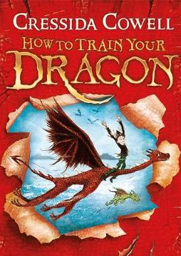
How to Train Your Dragon
Chapter 3 – Heroes or exiles
Dictionary Corner
There are lots of new and interesting words in this chapter. Use a dictionary or ask a grown up what these words mean.
- primeval
- defiance
- fortification

- What is a gorge?

- Describe the friendship between Hiccup and Fishlegs.

- How will Snotlout react to Hiccups small dragon?

- What does ‘Heroes or exile’ mean?

What do you think makes a good hero? Draw your hero and write a few words or sentences to describe them.
My Hero

