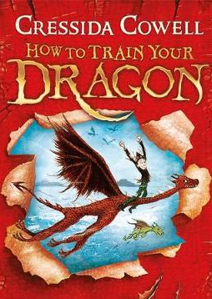
How to Train Your Dragon
Chapter 2 – Inside the dragon nursery
Dictionary Corner
There are lots of new and interesting words in this chapter. Use a dictionary or ask a grown up what these words mean.
- Claustrophobic
- Ignorance
- Hesitated

- How are the characters of Snotlout and Hiccup different?

- How do you think Hiccup might be feeling inside the cave?

- ‘Being frightened is not the same as being a coward.’ What does this mean?

Look at page 36. Use the information to draw and label a picture of a Gronckle.
The Gronckle

