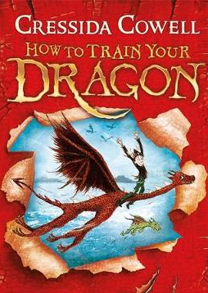
How to Train Your Dragon
Chapter 1 – Task
What are your first impressions of the main characters so far?
Draw a picture and write a few words or sentences to describe each character.

Character | Picture | Description
Hiccup
Fishlegs
Gobber
Dogsbreath
Snotface
Wartihog

