Our Class Book for this half term is ‘How to Train Your Dragon’ by Cressida Cowell.
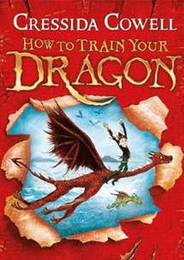
Our class novel is our little gift to you and is ready for you to collect in school now.

- It would be lovely if we could read this book together.

- After each chapter I will set you a task or an activity. Even if you can’t do the work it would be lovely if you could read the book either by yourself or an adult could read it to you.

- I’d love to see the tasks and activities you have created. If you want to you could take a photo and email them to me or if you complete your work on the computer you could email me your work.

My email address is:
bardelll@st-osburgs.coventry.sch.uk
Hope you hear from some of you soon .

