Yr 3 October Half Term Project

Over half term we would like you to choose two things from the grid to complete.
Have fun and stay safe.
Mrs Bardell & Miss Wood

  Learn to tie your shoe laces | Make a cake or biscuits with a grown up  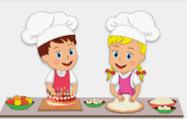 | 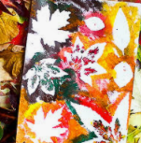  Create your own autumn art
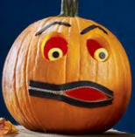  Help carving a pumpkin | Go on an autumn walk  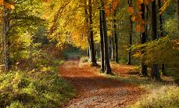 | Write a poem about autumn  

