
Choose two activities from the grid below to complete for RE
Year 3 Remote Learning Plan
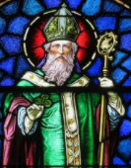  Research a saint and write a fact about them and their life. | Write about the parables of the sower in your own words.  What does the parable mean?  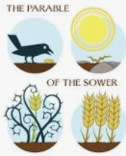 | Learn about the Rosary.  Pray the Rosary at home with your family.  

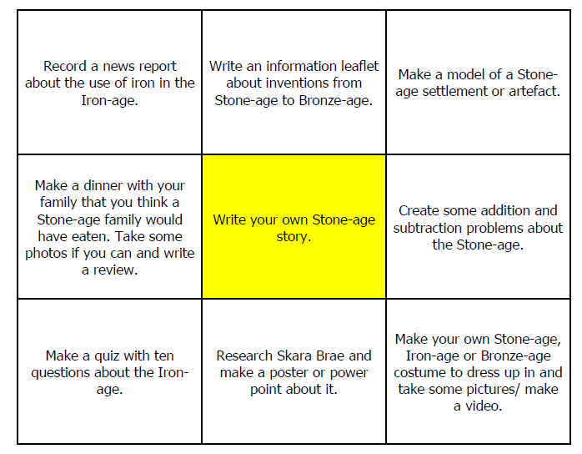
Choose three activities from the grid below to complete for Theme

