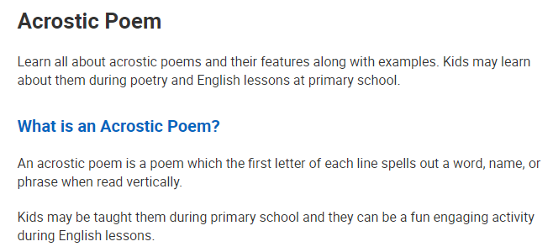
Acrostic Poem Help sheet

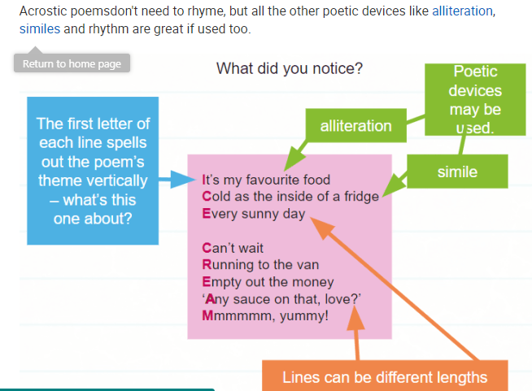
Now have a go at doing your own Children in Need Acrostic Poem. You can decorate it too if you like.
Use the words
SPOTS PUDSEY CHILDREN IN NEED

