Friday 13th November 2020
Children In Need

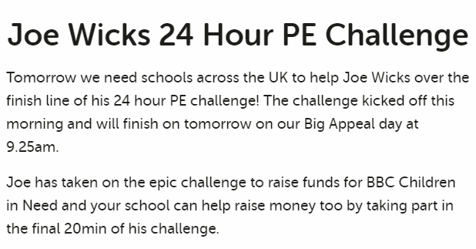
https://www.bbcchildreninneed.co.uk/schools/primary-school/


