Chaplaincy Chat – Autumn 1

Welcome to the first Chaplaincy Chat newsletter of the year.
We will be talking about what happened this year with the chaplaincy team. Lots of things happened this term! We started this term by forming our group of members with pupils from Year 3 to 6, 20 students applied by writing to Mrs Rynott about how we could help others to follow in Jesus’s footsteps, with all of us getting a spot on the team.
Our newly found team went checking the rooms to make sure they all had a crucifix ( Year 3 and 4 members) .The set of virtues and values for this term are Compassionate and Loving and we gave out posters for each classroom on these.
Chaplaincy fundraising started off bright with Brighten Up For Harvest from CAFOD to come dressed up brightly with the payment of £1 or food for a local foodbank. Then we had Saint Francis of Assisi day where we could dress up as an animal for free and we could have animal teddies on our desk and also animal print clothing.
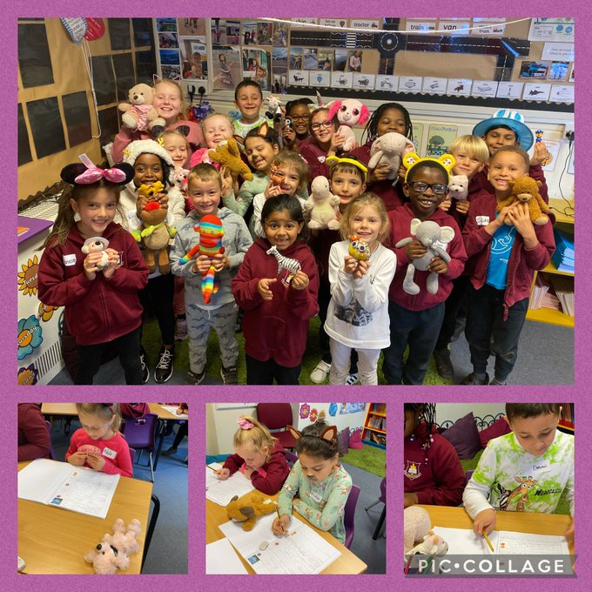
By Dominic, Chloe and Bella Y5


