
Choose two activities from the grid below to complete for RE
Year 4 Remote Learning Plan
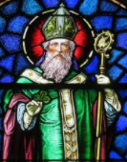  Research a saint and write a fact about them and their life. | Write about the parables of the sower in your own words.  What does the parable mean?  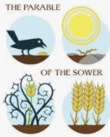 | Learn about the Rosary.  Pray the Rosary at home with your family.  

Choose three activities from the grid below to complete for Theme
Write a newspaper  report  about a Volcanic  eruption | Draw and label a  cross section diagram  of a volcano | Make a volcano  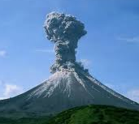
Explain what happens during  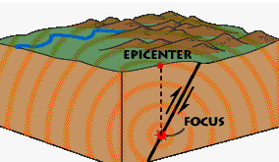  an earth quake | Extreme Earth | Write a diary as an  earth quake survivor
Design a poster to show different extreme natural  events | Write an information booklet about a Tsunami  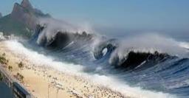 | Explain how a tornado  is formed and the destruction it can cause

