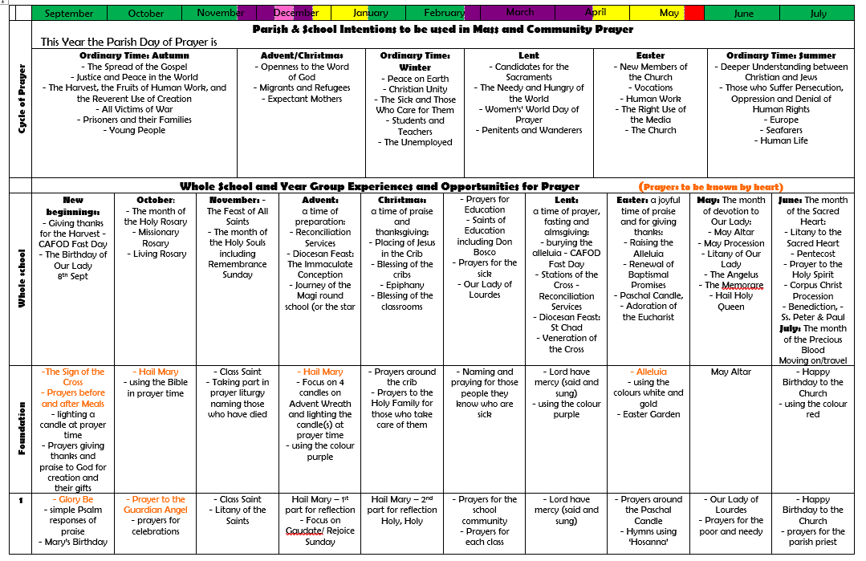
St Osburg’s /Diocesan Progression in Prayer throughout the year groups


