Rosa sat, so Ruby could walk, and Kamala could run.
Rosa Parks
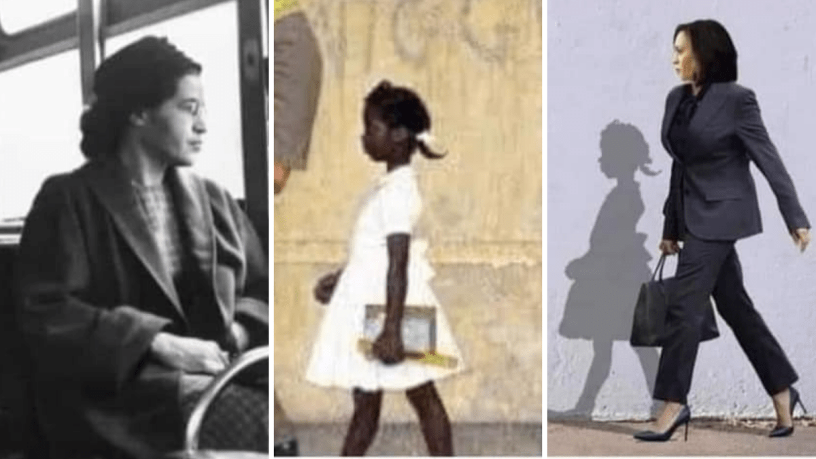
Draw and write about the people in your life who have helped you to reach your potential
Kamala Harris
Ruby Bridges

