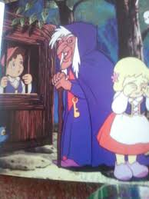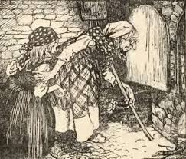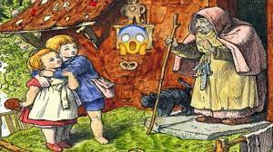

Write a detailed description of the witch from Hansel & Gretel. Include a variety of sentence types and language features. Imagine that somebody is going to draw the witch from your description- would they be able to do that? That is what we are trying to do for the reader.
Consider your vocabulary choices- create a bank og chottings of descriptive vocabulary before you begin.

Write a detailed description of the witch from Hansel & Gretel. Include a variety of sentence types and language features. Imagine that somebody is going to draw the witch from your description- would they be able to do that? That is what we are trying to do for the reader.
Consider your vocabulary choices- create a bank og chottings of descriptive vocabulary before you begin.

