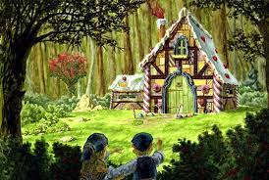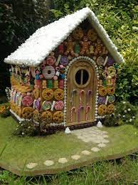

Write a detailed description of the house from Hansel & Gretel. Include a variety of sentence types and language features. Imagine that somebody is going to draw the house from your description- would they be able to do that? That is what we are trying to for the reader.

Write a detailed description of the house from Hansel & Gretel. Include a variety of sentence types and language features. Imagine that somebody is going to draw the house from your description- would they be able to do that? That is what we are trying to for the reader

