Circle the box with the greatest amount.
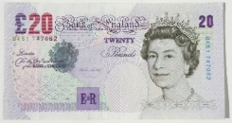 |  | 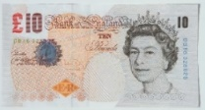 |  | 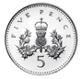  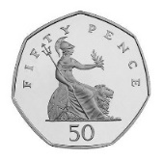  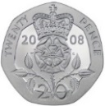 |  | 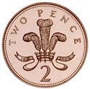  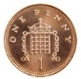  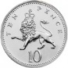
£____ £____ ____p ____p

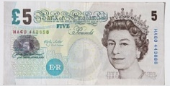
£____ £____ ____p ____p

Circle who has the least?




I have £64 I have 64p I have 58p I have £58

Use <, > = to compare the amounts.
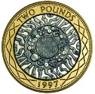
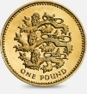

£____ £____

____p ____p

£____ £____

£____ £____


Anna has three coins in her hand.

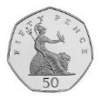
Larry says, “I have more than you because I have a 50 pence coin.”
Is he correct? ____
Explain why.
___ + ___ + ___
___ + ___ + ___
___ + ___ + ___
___ + ___ + ___

__________________________________________________________________________

