A Collection of Winter Poetry
For KS1 and EYFS

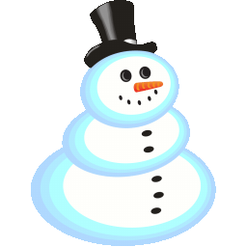

Great Big Snowman

I’m a great big snowman,
Tall and fat
Here’s my tummy
Here’s my hat
Coal for my eyes
And a carrot nose
I’m all snow from
Head to toes

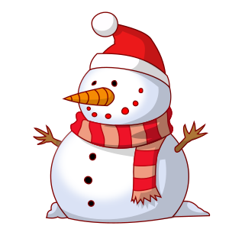

The Snowky Pokey
(To the tune of Hokey Pokey)

You put your right mitten in
Your right mitten out
Your right mitten in
And you shake it all about

You do the snowky pokey
And you turn around
That’s what it’s all about

Repeat with
- Left mitten
- Right boot
- Left boot
- Woolly hat
- Whole self

Penguins

Penguins, penguins having fun
Waddling in the Winter sun
Waddling fast and waddling slow
Waddling to and waddling fro
Penguins, penguins having fun
Waddling in the Winter sun

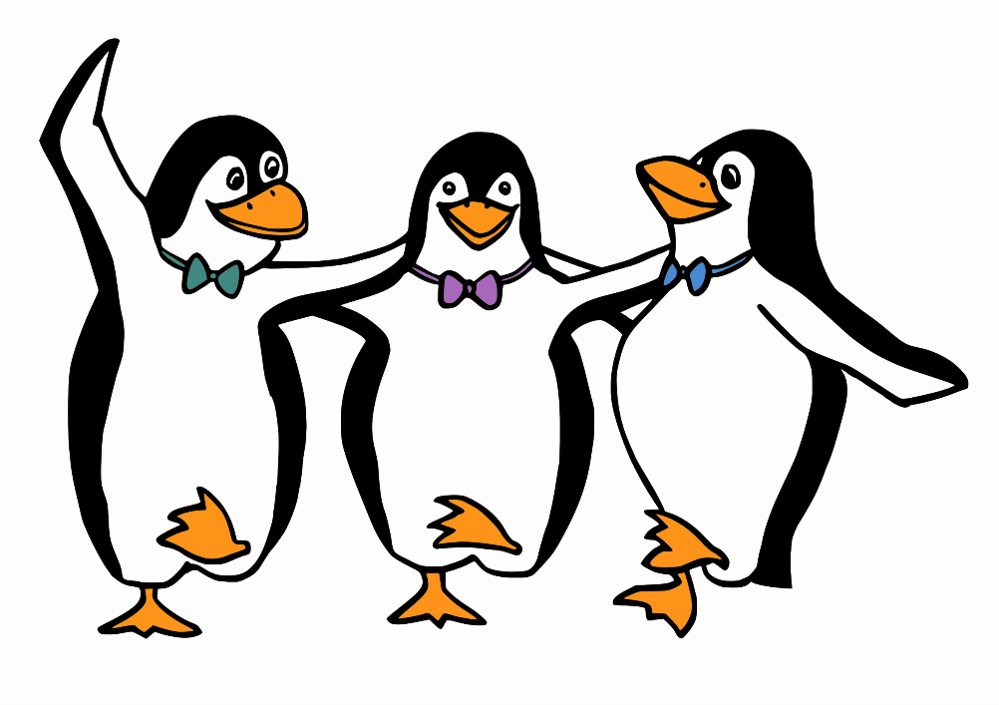

A Snowflake Fell

A snowflake fell into my hand,
A tiny, fragile gem,
A frosty crystal flowerlet
With petals but no stem.
I wondered at the beauty
Of its intricate design,
I breathed, the snowflake vanished
But for moments, it was mine.

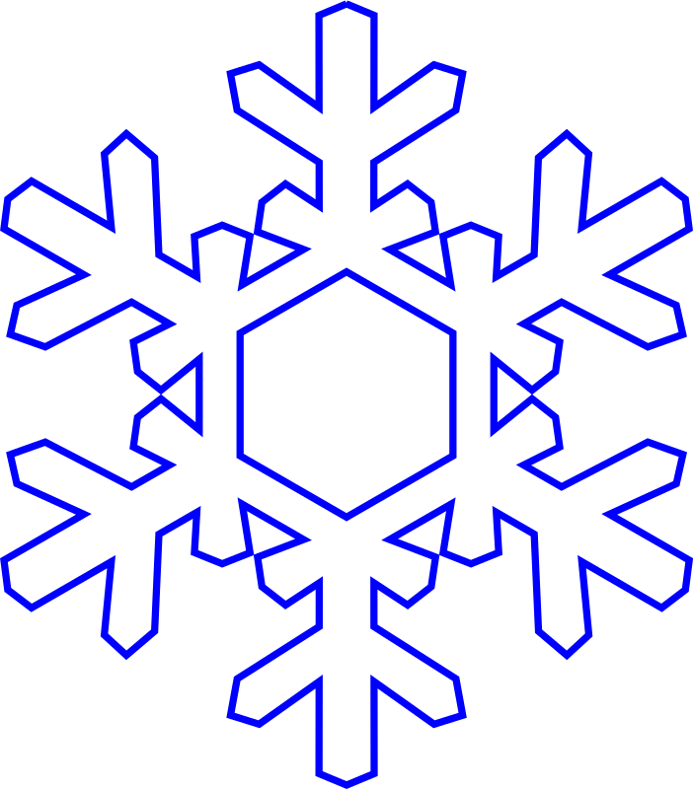

When Santa Claus comes

A good time is coming,
I wish it were here
The very best time
In the whole of the year
I’m counting each day
On my fingers and thumbs
On the weeks that must pass
Before Santa Claus comes
Then when the first snowflakes
Begin to fall down
And the wind whistles sharp
And the branches are brown
I’ll not mind the cold
Though my fingers it numbs
As it brings forth the time
When Santa Claus comes.

A Chubby Snowman

A chubby little snowman
Had a carrot nose
Along came a bunny
And what do you suppose?

That hungry little bunny
Looking for some lunch
Grabbed the snowman’s nose
Nibble, nibble, crunch.

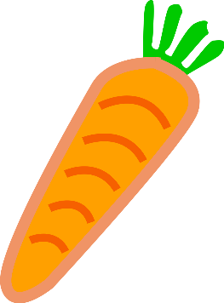

Winter Animals

Polar bears
Look snowy white
Arctic hares
Hop out of sight
Sweet baby seals
Change as they grow
Snowy owls fly
High and low
How do they all
Stay snug and warm
In snow and ice
And freezing storm?

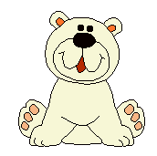
Snowflakes

Snowflakes, snowflakes
Twirl around
Snowflakes, snowflakes
Touch the ground
Snowflakes, snowflakes
Land on my nose
Snowflakes, snowflakes
Freeze my toes
Snowflakes, snowflakes
In the air
Snowflakes, snowflakes
Everywhere!

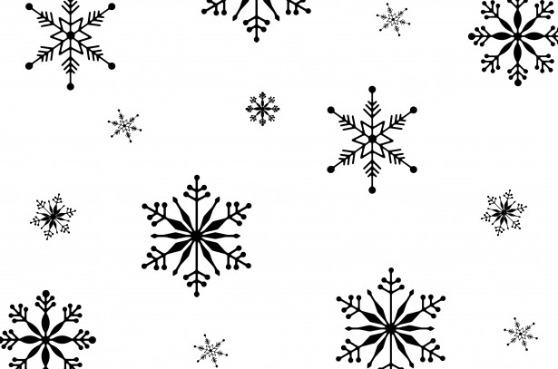
Winter

The birds are gone
The world is white
The winds are wild
They chill and bite
The ground is thick
With slush and sleet
And I can barely
Feel my feet!

Winter Animals

Winter is cold
There is snow in the sky
The squirrel gathers nuts
And the wild geese fly
The fluffy red fox
Has his fur to keep warm
The bear’s in his cave
Sleeping all through the storm.

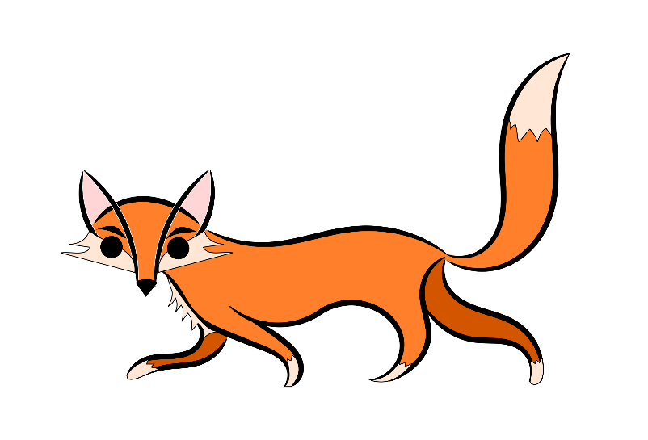

Snow Kisses

If you go out when it’s snowing
And look up to the sky
You’ll feel lots of icy kisses
As the snowflakes flutter by

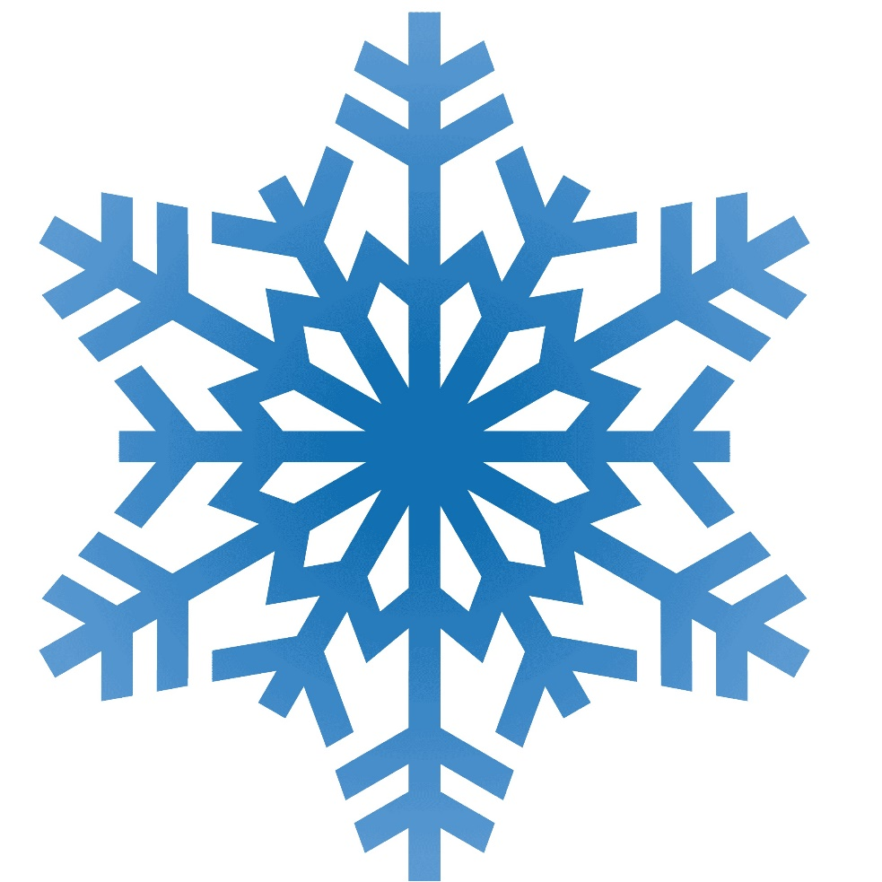

I’m a Little Reindeer

I’m a little reindeer
Ready to fly
I’ll pull Santa’s sleigh
Up to the sky
Christmas is here
We can’t be late
All of the children
Just can’t wait!

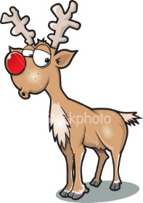

Merry Christmas

Carols in the distance
Laughter everywhere
I can smell Christmas
Floating in the air

Candy canes and bonbons
Angels top the tree
There’s presents over yonder
One for you and one for me

Tinsel wrapping round and round
Candles light the night
Making Santa’s journey
Sparkly and bright

A very merry Christmas
To your family, my friend
May your new year bring happiness
And may the joyful times not end

Candy Stick

I took a lick
Of a candy stick
And oh, it did taste yummy
It used to be on
The Christmas tree
And now it’s in my tummy.

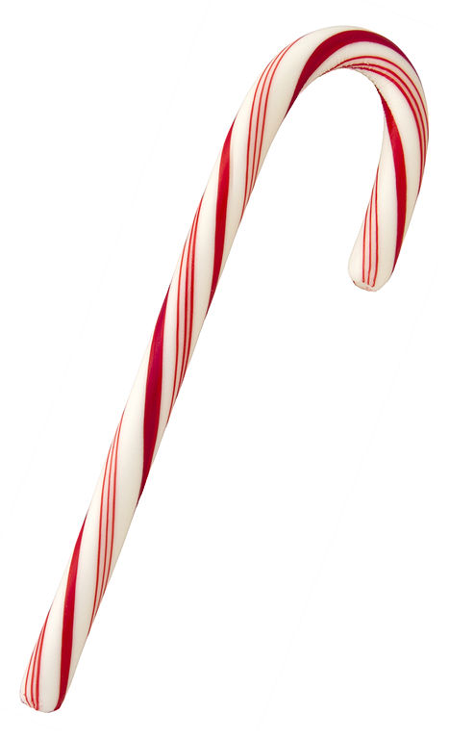

A Christmas Poem

The funniest face
Looked out at me
From a silver ball
On the Christmas tree

At first I thought
It was Santa’s elf
But I looked again
And it was just myself!



Five Yummy Gingerbread

Five yummy gingerbread
Sitting on a plate
The first one said
“Boy, we smell great”
The second one said
“There’s a chill in the air”
The third one said
“There’s hungry children everywhere!”
The fourth one said
“I think we’d better run!”
The fifth one said
“Oh no, here the children come!”
Then the children grabbed them
Munch! Crunch! Munch!
The five little gingerbreads
Turned into lunch!
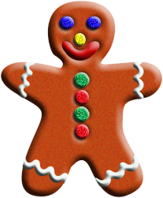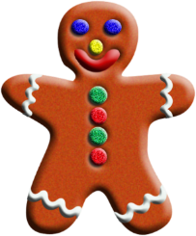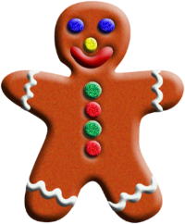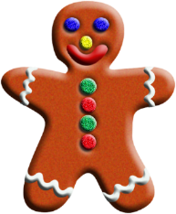

Little Pine Tree

I’m a little pine tree
As you can see
All the other pine trees
Are bigger than me
Maybe when I grow up
Then I’ll be
A great big merry Christmas tree

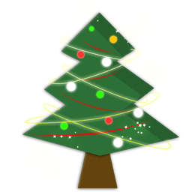

Christmas Star

Twinkle twinkle Christmas star
Way up high is where you are
Shining there for all to see
On the tip top of our tree
Twinkle twinkle star so bright
Shine up there til morning light

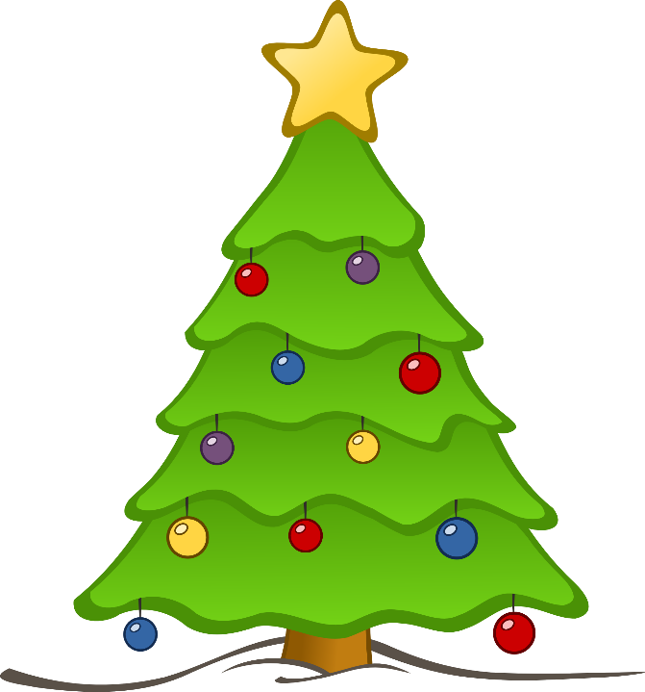

Christmas Tree

One little star
On the top of the tree
Two little presents
Underneath for me
Three silver ropes
Twisted round the tree
Four coloured lights
Shining prettily
Five shiny balls
Glowing silverly
Oh what a sight
For us to see

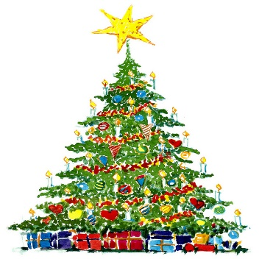

Five Little Reindeer

Five little reindeer
Dancing on a roof
One fell off and banged his hoof
Santa called the doctor
And the doctor said
“Put that reindeer straight to bed!”

Repeat with four, three, two, one…

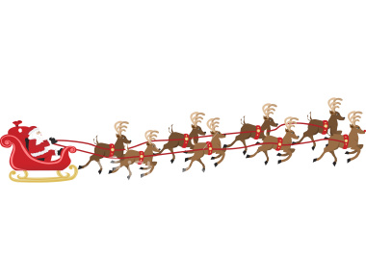

Falling Snow

See the pretty snowflakes
Falling from the sky
On the wall and housetops
Soft and thick they lie
On the window ledges
On the branches bare
Now how fast they gather
Filling all the air
Look into the garden
Where the grass was green
Covered by the snowflakes
Not a blade is seen
Now the bare black bushes
All look soft and white
Every twig is laden
What a pretty sight

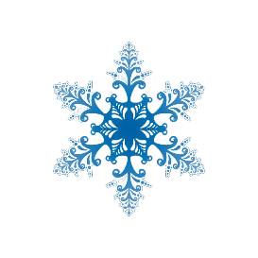
I love Winter

I love Winter
It’s snow with sleds
It’s warm snuggly beds
It’s silver snowflakes
It’s skating on lakes
It’s snowmen that stand
On white snowy land
It’s robins that feed
On sunflower seed
It’s angels that pose
In wintertime clothes
It’s a polka dot sky
It’s sowing that’s why
I love Winter

Snowflakes

Snowflakes are beautiful
Pure and white
And just like us
No two are alike

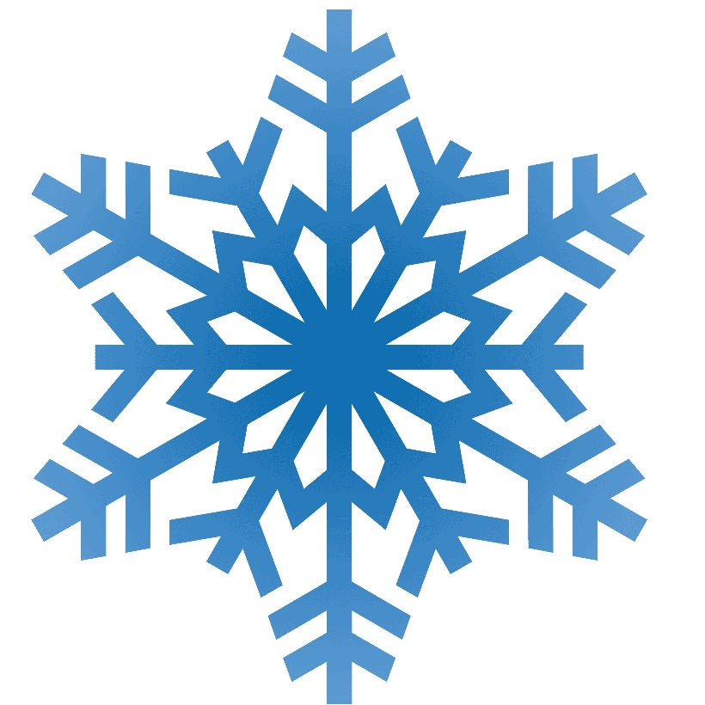

Jack Frost

Someone painted pictures on my
Windowpane last night –
Willow trees with trailing boughs
And flowers, frosty white,
And lovely crystal butterflies;
But when the morning sun
Touched them with its golden beams,
They vanished one by one.
by Helen Bayley Davis

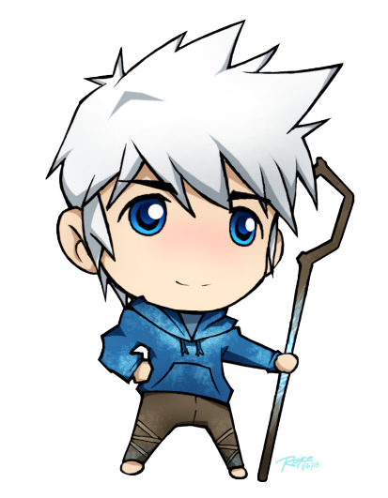

What I love about Winter

Frozen lakes
Hot Pancakes
Lots of snow
Hot cocoa
Skates and skis
Evergreen trees
Funny hats
Thermostats
Sunsets blaze
Holidays
Snowball fights
Fireplace nights
Chimneys steaming
Winter dreaming
by Douglas Florian

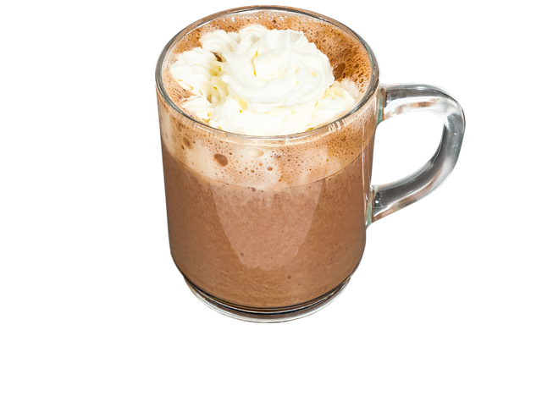

Winter Morning Poem
Winter is the king of showmen,
Turning tree stumps into snow men,
And houses into birthday cakes,
And spreading sugar over lakes.
Smooth and clean and frosty white,
The world looks good enough to bite.
That's the season to be young
Catching snowflakes on your tongue.
Snow is snowy when it's snowing
I'm sorry it's slushy when it's going.
by Ogden Nash

Snow Day
Snow on the mountain tops,
Snow on the trees,
Snow everywhere I walk,
Way up to my knees.
Scoop the snow up with your hand
And roll into a ball.
We can make a fine snow man
Standing white and tall.
What a fine December day
With all the snow I see,
I want to go outside to play
When winter visits me.
by Writer Fox

